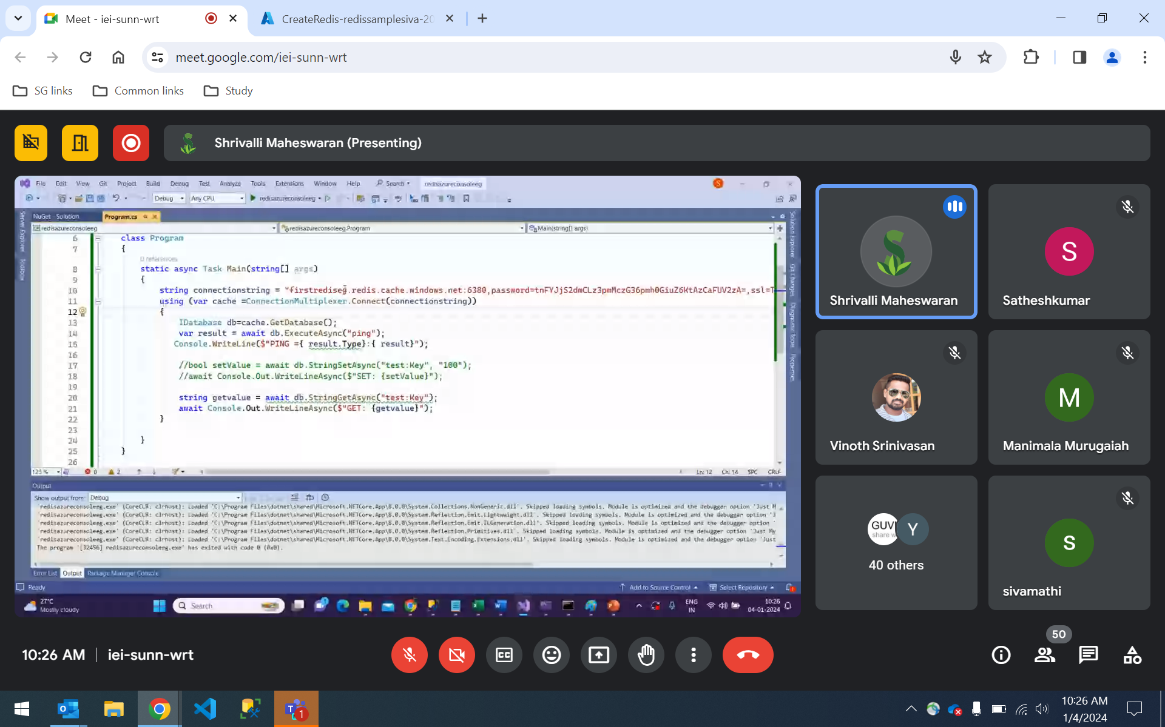

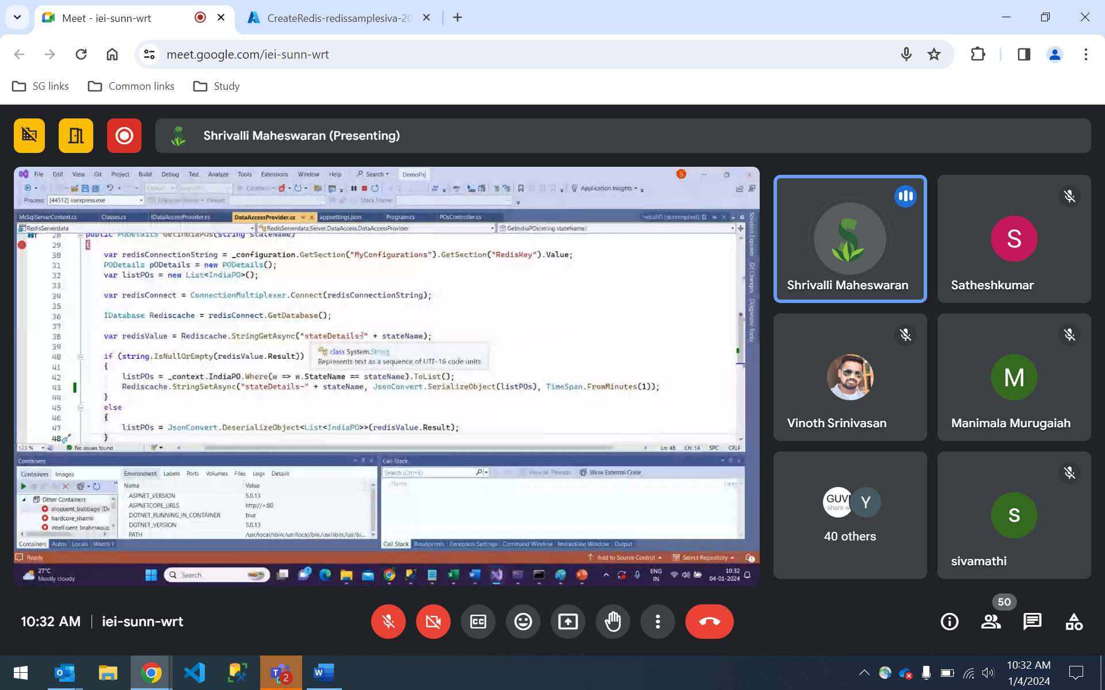

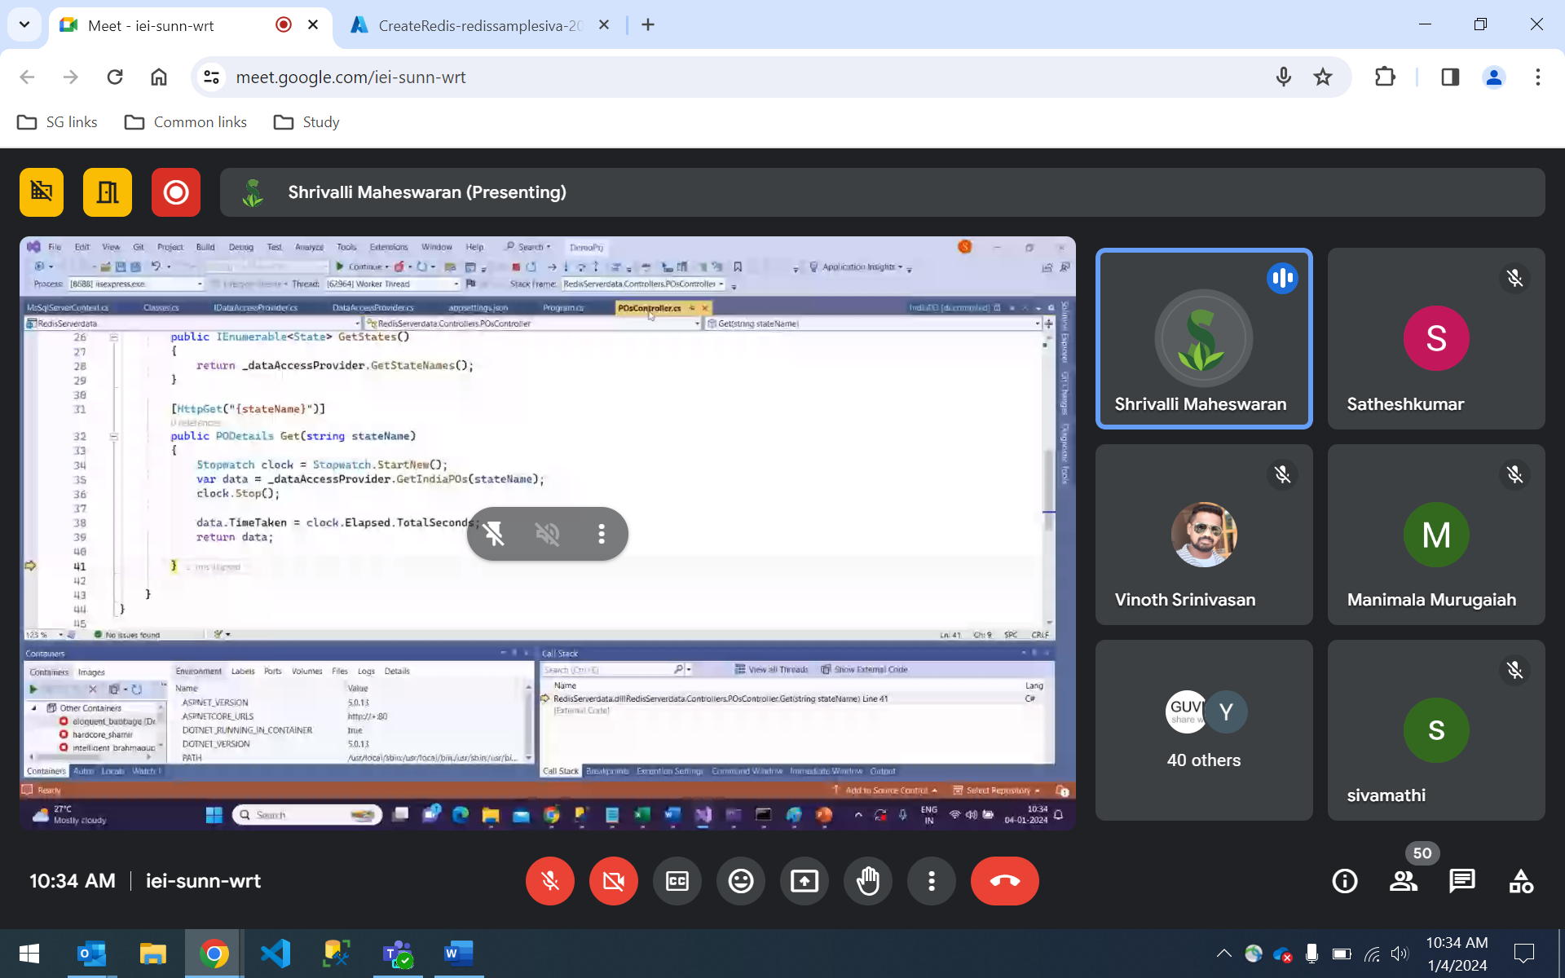

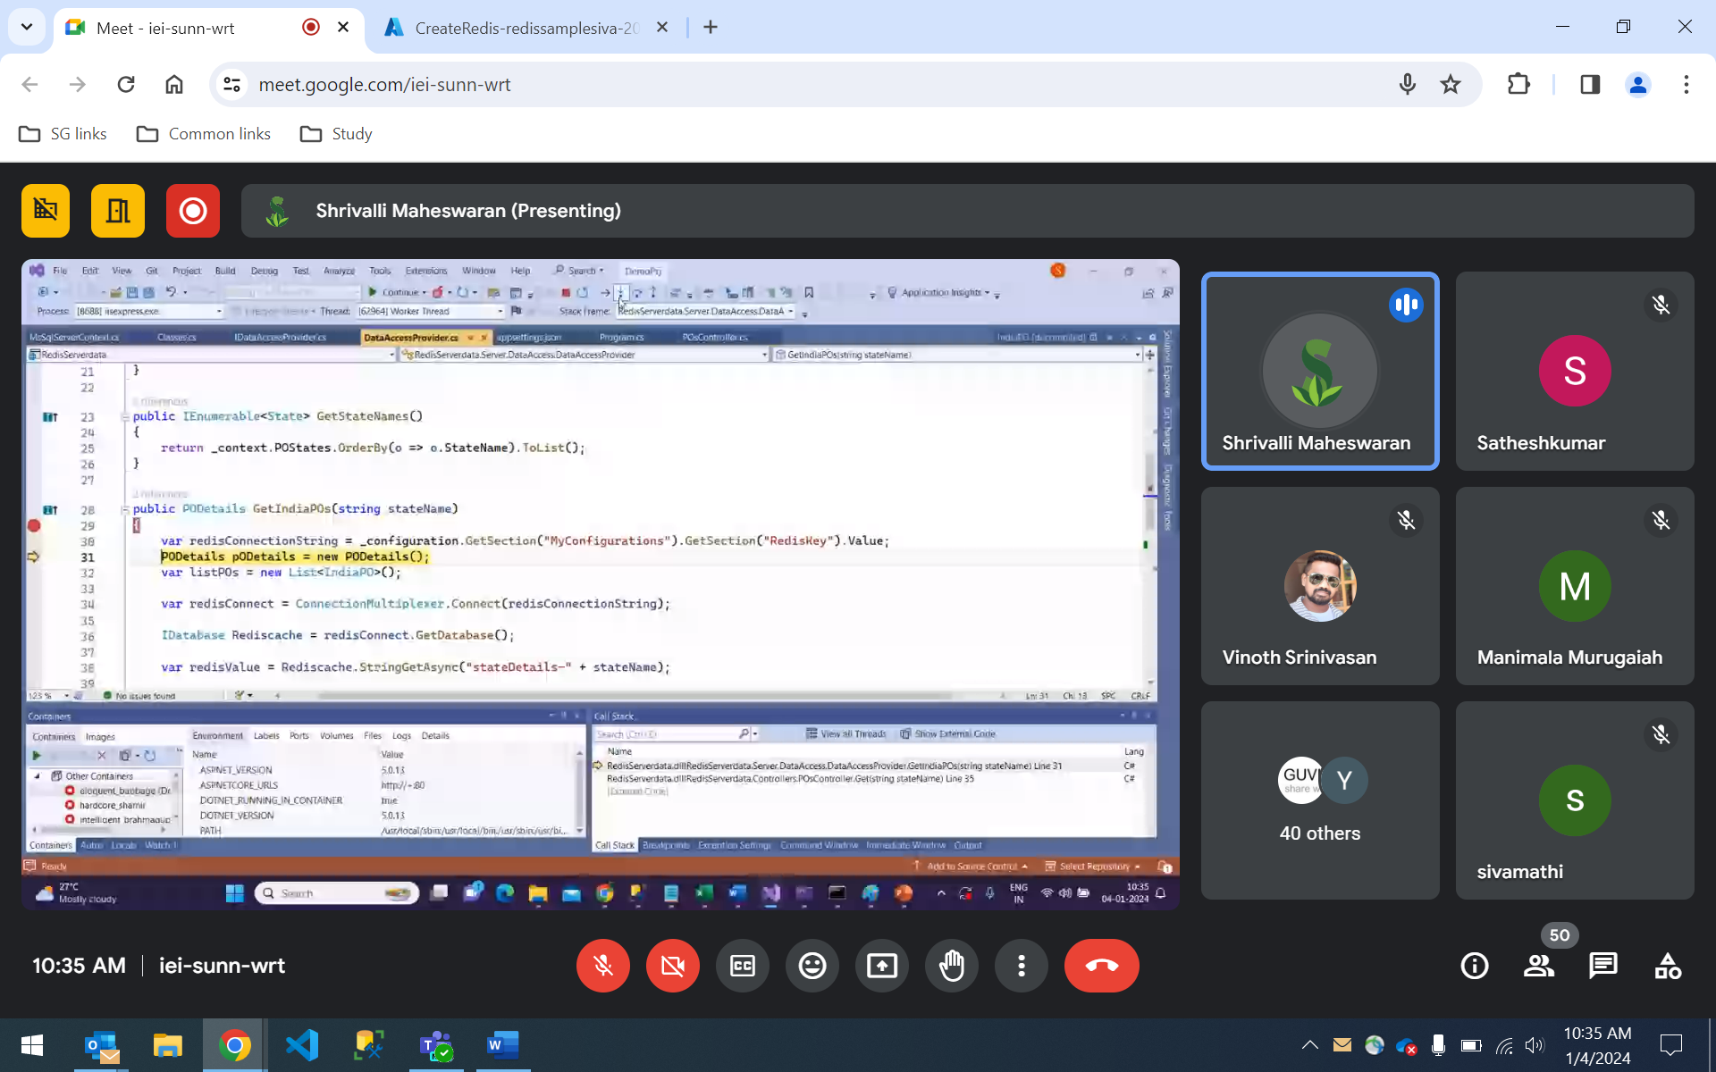

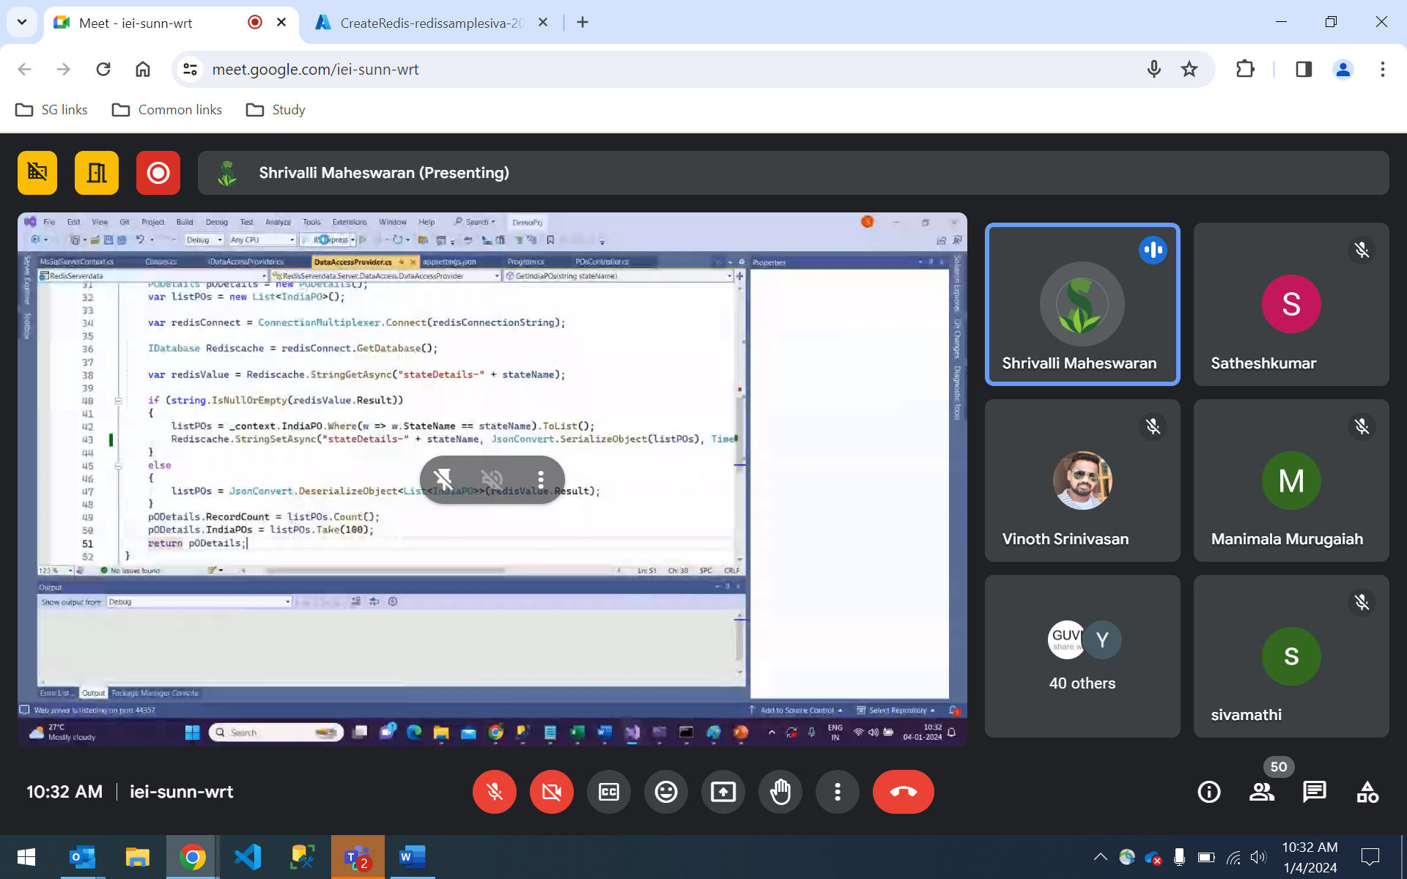

public PODetails GetIndiaPOs(string stateName) { PODetails pODetails = new PODetails(); var listPOs = new List<IndiaPO>(); var redisConnectionString = _configuration.GetSection("MyConfigurations").GetSection("RedisKey").Value; var redisConnect = ConnectionMultiplexer.Connect(redisConnectionString); IDatabase Rediscache = redisConnect.GetDatabase(); var redisValue = Rediscache.StringGetAsync("stateDetails-" + stateName); if (string.IsNullOrEmpty(redisValue.Result))

class Program { static async Task Main(string[] args) { string connectionstring = "firstrediseg.redis.cache.windows.net:6380,password=tnFYJjS2dmCLz3pmMczG36pmh0GiuZ6KtAzCaFUV2zA=,ssl=True,abortConnect=False"; using (var cache =ConnectionMultiplexer.Connect(connectionstring)) { IDatabase db=cache.GetDatabase(); var result = await db.ExecuteAsync("ping"); Console.WriteLine($"PING ={ result.Type}:{ result}");